1. INTRODUCTION

The H-1B is an employment-based, non-immigrant visa category for temporary foreign workers in the United States. For a foreign national to apply for H1-B visa, a US employer must offer a job and petition for H-1B visa with the US immigration department. This is the most common visa status applied for and held by international students once they complete college / higher education (Masters, PhD) and work in a fulltime position. H-1B visa class is very industry relevant and many individuals and companies rely heavily on this yearly allotment. Currently there’s no way for knowing how application attributes contribute towards the final visa-status outcome.

In this report, we proceed in the following manner to achieve our objective. First, we introduce the dataset that we experimented on and our analysis on it. Then we talk about the details of our predictive task. Then we describe the various features we extracted from the data based on our analysis. Then, we present the related work that has been done on H1- B visa classification. In the last section, we present our results and conclusion.

This project on Data Science was implemented through python, using the concepts of Pandas, Numpy, Seaborn, Matplotlib and was done in jupyter-notebook.

2. DATA SCIENCE

Data science is a multidisciplinary blend of data inference, algorithm development, and technology in order to solve analytically complex problems.
At the core is data. Troves of raw information, streaming in and stored in enterprise data warehouses. Much to learn by mining it. Advanced capabilities we can build with it. Data science is ultimately about using this data in creative ways to generate business value.
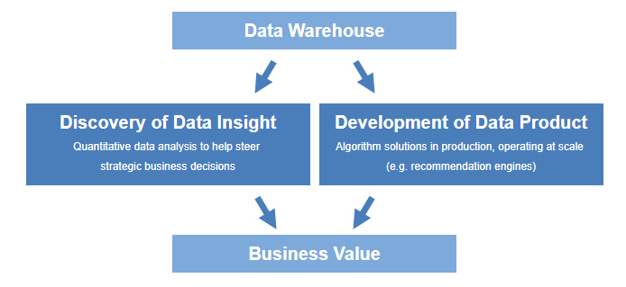

2.1 Data science – discovery of data insight
This aspect of data science is all about uncovering findings from data. Diving in at a granular level to mine and understand complex behaviors, trends, and inferences. It's about surfacing hidden insight that can help enable companies to make smarter business decisions. For example:
- Netflix data mines movie viewing patterns to understand what drives user interest, and uses that to make decisions on which Netflix original series to produce.

- Target identifies what are major customer segments within it's base and the unique shopping behaviours within those segments, which helps to guide messaging to different market audiences.
- Proctor & Gamble utilizes time series models to more clearly understand future demand, which help plan for production levels more optimally.
How do data scientists mine out insights? It starts with data exploration. When given a challenging question, data scientists become detectives. They investigate leads and try to understand pattern or characteristics within the data. This requires a big dose of analytical creativity.
Then as needed, data scientists may apply quantitative technique in order to get a level deeper – e.g. inferential models, segmentation analysis, time series forecasting, synthetic control experiments, etc. The intent is to scientifically piece together a forensic view of what the data is really saying.
This data-driven insight is central to providing strategic guidance. In this sense, data scientists act as consultants, guiding business stakeholders on how to act on findings.

2.2 Data science – development of data product
A "data product" is a technical asset that: (1) utilizes data as input, and (2) processes that data to return algorithmically-generated results. The classic example of a data product is a recommendation engine, which ingests user data, and makes personalized recommendations based on that data. Here are some examples of data products:
- Amazon's recommendation engines suggest items for you to buy, determined by their algorithms. Netflix recommends movies to you. Spotify recommends music to you.
- Gmail's spam filter is data product – an algorithm behind the scenes processes incoming mail and determines if a message is junk or not.
- Computer vision used for self-driving cars is also data product – machine learning algorithms are able to recognize traffic lights, other cars on the road, pedestrians, etc.
This is different from the "data insights" section above, where the outcome to that is to perhaps provide advice to an executive to make a smarter business decision.

In contrast, a data product is technical functionality that encapsulates an algorithm, and is designed to integrate directly into core applications. Respective examples of applications that incorporate data product behind the scenes: Amazon's homepage, Gmail's inbox, and autonomous driving software.
Data scientists play a central role in developing data product. This involves building out algorithms, as well as testing, refinement, and technical deployment into production systems. In this sense, data scientists serve as technical developers, building assets that can be leveraged at wide scale.

This is different from the "data insights" section above, where the outcome to that is to perhaps provide advice to an executive to make a smarter business decision. In contrast, a data product is technical functionality that encapsulates an algorithm, and is designed to integrate directly into core applications. Respective examples of applications that incorporate data product behind the scenes: Amazon's homepage, Gmail's inbox, and autonomous driving software.
Data scientists play a central role in developing data product. This involves building out algorithms, as well as testing, refinement, and technical deployment into production systems. In this sense, data scientists serve as technical developers, building assets that can be leveraged at wide scale.

2.3 What is data science – the requisite skill set
Data science is a blend of skills in three major areas:
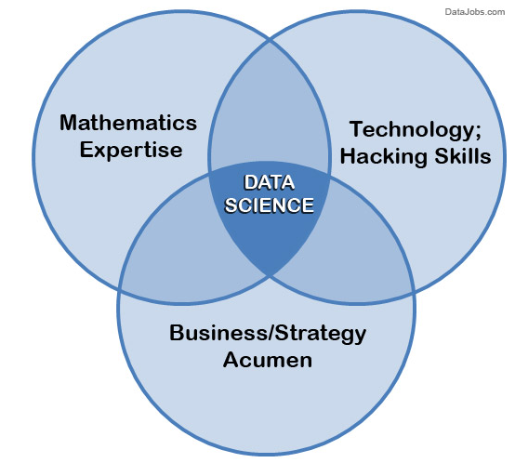

2.3.1 Mathematics Expertise
At the heart of mining data insight and building data product is the ability to view the data through a quantitative lens. There are textures, dimensions, and correlations in data that can be expressed mathematically. Finding solutions utilizing data becomes a brain teaser of heuristics and quantitative technique. Also, data science is not all about statistics. While statistics is important, it is not the only type of math utilized. First, there are two branches of statistics – classical statistics and Bayesian statistics. When most people refer to stats they are generally referring to classical stats, but knowledge of both types is helpful. Furthermore, many inferential techniques and machine learning algorithms lean on knowledge of linear algebra. For example, a popular method to discover hidden characteristics in a data set is SVD, which is grounded in matrix math and has much less to do with classical stats.

2.3.2 Technology and Hacking
We're referring to the tech programmer subculture meaning of hacking – i.e., creativity and ingenuity in using technical skills to build things and find clever solutions to problems.
Hacking ability is important because data scientists utilize technology in order to wrangle enormous data sets and work with complex algorithms, and it requires tools far more sophisticated than Excel. Data scientists need to be able to code — prototype quick solutions, as well as integrate with complex data systems. Core languages associated with data science include SQL, Python, R etc. On the periphery are Java, Scala, Julia, and others. But it is not just knowing language fundamentals but be able to creatively navigate their way through technical challenges in order to make their code work.
Along these lines, a data science hacker is a solid algorithmic thinker, having the ability to break down messy problems and recompose them in ways that are solvable. This is critical because data scientists operate within a lot of algorithmic complexity. They need to have a strong mental comprehension of high-dimensional data and tricky data control flows. Full clarity on how all the pieces come together to form a cohesive solution.

2.3.3 Strong Business Acumen
It is important for a data scientist to be a tactical business consultant. Working so closely with data, data scientists are positioned to learn from data in ways no one else can. That creates the responsibility to translate observations to shared knowledge, and contribute to strategy on how to solve core business problems. This means a core competency of data science is using data to cogently tell a story. No data-puking – rather, present a cohesive narrative of problem and solution, using data insights as supporting pillars, that lead to guidance.
Having this business acumen is just as important as having acumen for tech and algorithms. There needs to be clear alignment between data science projects and business goals. Ultimately, the value doesn't come from data, math, and tech itself. It comes from leveraging all of the above to build valuable capabilities and have strong business influence.

2.4 Analytics and machine learning – how it ties to data science
There are a slew of terms closely related to data science that is hoped to add some clarity around.

What is Analytics?
Analytics has risen quickly in popular business lingo over the past several years; the term is used loosely, but generally meant to describe critical thinking that is quantitative in nature. Technically, analytics is the "science of analysis" — put another way, the practice of analyzing information to make decisions.
Is "analytics" the same thing as data science? Depends on context. Sometimes it is synonymous with the definition of data science that we have described, and sometimes it represents something else. A data scientist using raw data to build a predictive algorithm falls into the scope of analytics. At the same time, a non-technical business user interpreting pre-built dashboard reports (e.g. GA) is also in the realm of analytics, but does not cross into the skill set needed in data science. Analytics has come to have fairly broad meaning. At the end of the day, as long as you understand beyond the buzzword level, the exact semantics don't matter much.

What is the difference between an analyst and a data scientist?
"Analyst" is somewhat of an ambiguous job title that can represent many different types of roles (data analyst, marketing analyst, operations analyst, financial analyst, etc). What does this mean in comparison to data scientist?
- Data Scientist: Specialty role with abilities in math, technology, and business acumen. Data scientists work at the raw database level to derive insights and build data product.
- Analyst: This can mean a lot of things. Common thread is that analysts look at data to try to gain insights. Analysts may interact with data at both the database level or the summarized report level.
Thus, "analyst" and "data scientist" is not exactly synonymous, but also not mutually exclusive.

2.5 What is Machine Learning?
Machine learning is a term closely associated with data science. It refers to a broad class of methods that revolve around data modeling to
(1) algorithmically make predictions, and
(2) algorithmically decipher patterns in data.
- Machine learning for making predictions — Core concept is to use tagged data to train predictive models. Tagged data means observations where ground truth is already known. Training models means automatically characterizing tagged data in ways to predict tags for unknown data points. E.g. a credit card fraud detection model can be trained using a historical record of tagged fraud purchases. The resultant model estimates the likelihood that any new purchase is fraudulent. Common methods for training models range from basic regressions to complex neural nets. All follow the same paradigm known as supervised learning.

- Machine learning for pattern discovery — Another modeling paradigm known as unsupervised learning tries to surface underlying patterns and associations in data when no existing ground truth is known (i.e. no observations are tagged). Within this broad category of methods, the most commonly used are clustering techniques, which algorithmically detect what are the natural groupings that exist in a data set. For example, clustering can be used to programmatically learn the natural customer segments in a company's user base.

3. PYTHON

Python is an interpreted, object-oriented, high-level programming language with dynamic semantics. Its high-level built in data structures, combined with dynamic typing and dynamic binding, make it very attractive for Rapid Application Development, as well as for use as a scripting or glue language to connect existing components together. Python's simple, easy to learn syntax emphasizes readability and therefore reduces the cost of program maintenance.
Python supports modules and packages, which encourages program modularity and code reuse. The Python interpreter and the extensive standard library are available in source or binary form without charge for all major platforms, and can be freely distributed.
Often, programmers fall in love with Python because of the increased productivity it provides. Since there is no compilation step, the edit-test-debug cycle is incredibly fast. Debugging Python programs is easy: a bug or bad input will never cause a segmentation fault. Instead, when the interpreter discovers an error, it raises an exception. When the program doesn't catch the exception, the interpreter prints a stack trace. A source level debugger allows inspection of local and global variables, evaluation of arbitrary expressions, setting breakpoints, stepping through the code a line at a time, and so on. The debugger is written in Python itself, testifying to Python's introspective power. On the other hand, often the quickest way to debug a program is to add a few print statements to the source: the fast edit-test-debug cycle makes this simple approach very effective.

3.1 PANDAS

Pandas is a Python package providing fast, flexible, and expressive data structures designed to make working with structured (tabular, multidimensional, potentially heterogeneous) and time series data both easy and intuitive. It aims to be the fundamental high-level building block for doing practical, real world data analysis in Python. Additionally, it has the broader goal of becoming the most powerful and flexible open source data analysis / manipulation tool available in any language. It is already well on its way toward this goal.
Pandas is well suited for many different kinds of data:
- Tabular data with heterogeneously-typed columns, as in an SQL table or Excel spreadsheet
- Ordered and unordered (not necessarily fixed-frequency) time series data.
- Arbitrary matrix data (homogeneously typed or heterogeneous) with row and column labels
- Any other form of observational / statistical data sets. The data actually need not be labeled at all to be placed into a pandas data structure
The two primary data structures of pandas, Series (1-dimensional) and DataFrame (2-dimensional), handle the vast majority of typical use cases in finance, statistics, social science, and many areas of engineering. For R users, DataFrame provides everything that R’s data.frame provides and much more. pandas is built on top of NumPy and is intended to integrate well within a scientific computing environment with many other 3rd party libraries.
Here are just a few of the things that pandas does well:
- Easy handling of missing data (represented as NaN) in floating point as well as non-floating point data
- Size mutability: columns can be inserted and deleted from DataFrame and higher dimensional objects
- Automatic and explicit data alignment: objects can be explicitly aligned to a set of labels, or the user can simply ignore the labels and let Series, DataFrame, etc. automatically align the data for you in computations
- Powerful, flexible group by functionality to perform split-apply-combine operations on data sets, for both aggregating and transforming data
- Make it easy to convert ragged, differently-indexed data in other Python and NumPy data structures into DataFrame objects
- Intelligent label-based slicing, fancy indexing, and subsetting of large data sets
- Intuitive merging and joining data sets
- Flexible reshaping and pivoting of data sets
- Hierarchical labeling of axes (possible to have multiple labels per tick)
- Robust IO tools for loading data from flat files (CSV and delimited), Excel files, databases, and saving / loading data from the ultrafast HDF5 format
- Time series-specific functionality: date range generation and frequency conversion, moving window statistics, moving window linear regressions, date shifting and lagging, etc.
Many of these principles are here to address the shortcomings frequently experienced using other languages / scientific research environments. For data scientists, working with data is typically divided into multiple stages: munging and cleaning data, analyzing / modeling it, then organizing the results of the analysis into a form suitable for plotting or tabular display. pandas is the ideal tool for all of these tasks.

3.2 NUMPY

NumPy is the fundamental package for scientific computing in Python. It is a Python library that provides a multidimensional array object, various derived objects (such as masked arrays and matrices), and an assortment of routines for fast operations on arrays, including mathematical, logical, shape manipulation, sorting, selecting, I/O, discrete Fourier transforms, basic linear algebra, basic statistical operations, random simulation and much more.
At the core of the NumPy package, is the ndarray object. This encapsulates n-dimensional arrays of homogeneous data types, with many operations being performed in compiled code for performance. There are several important differences between NumPy arrays and the standard Python sequences:
- NumPy arrays have a fixed size at creation, unlike Python lists (which can grow dynamically). Changing the size of an ndarray will create a new array and delete the original.
- The elements in a NumPy array are all required to be of the same data type, and thus will be the same size in memory. The exception: one can have arrays of (Python, including NumPy) objects, thereby allowing for arrays of different sized elements.
- NumPy arrays facilitate advanced mathematical and other types of operations on large numbers of data. Typically, such operations are executed more efficiently and with less code than is possible using Python’s built-in sequences.
- A growing plethora of scientific and mathematical Python-based packages are using NumPy arrays; though these typically support Python-sequence input, they convert such input to NumPy arrays prior to processing, and they often output NumPy arrays. In other words, in order to efficiently use much (perhaps even most) of today’s scientific/mathematical Python-based software, just knowing how to use Python’s built-in sequence types is insufficient - one also needs to know how to use NumPy arrays.
Advantages of using Numpy with Python:
- array oriented computing
- efficiently implemented multi-dimensional arrays

- designed for scientific computation

3.3 MATPLOTLIB

Matplotlib is a library for making 2D plots of arrays in Python. Although it has its origins in emulating the MATLAB graphics commands, it is independent of MATLAB, and can be used in a Pythonic, object oriented way. Although Matplotlib is written primarily in pure Python, it makes heavy use of Numpy and other extension code to provide good performance even for large arrays.
The Matplotlib code is conceptually divided into three parts: the pylab interface is the set of functions provided by matplotlib.pylab which allow the user to create plots with code quite similar to MATLAB figure generating code . The Matplotlib frontend or Matplotlib API is the set of classes that do the heavy lifting, creating and managing figures, text, lines, plots and so on . This is an abstract interface that knows nothing about output. The backends are device-dependent drawing devices, aka renderers, that transform the frontend representation to hardcopy or a display device .
Using the matplotlib there are following issues can cause some challenges:
- The library itself is huge, at something like 70,000 total lines of code.
- Matplotlib is home to several different interfaces (ways of constructing a figure) and capable of interacting with a handful of different backends. (Backends deal with the process of how charts are actually rendered, not just structured internally.)
- While it is comprehensive, some of matplotlib’s own public documentation is seriously out-of-date. The library is still evolving, and many older examples floating around online may take 70% fewer lines of code in their modern version.
One of Matplotlib’s most important features is its ability to play well with many operating systems and graphics backends. Matplotlib supports dozens of backends and output types, which means you can count on it to work regardless of which operating system you are using or which output format you wish. This cross-platform, everything-to-everyone approach has been one of the great strengths of

Matplotlib. It has led to a large user base, which in turn has led to an active developer base and Matplotlib’s powerful tools and ubiquity within the scientific Python world.

3.3.1 MATPLOTLIB.PYPLOT
Matplotlib.pyplot is a collection of command style functions that make matplotlib work like MATLAB. Each pyplot function makes some change to a figure: e.g., creates a figure, creates a plotting area in a figure, plots some lines in a plotting area, decorates the plot with labels, etc.
In matplotlib.pyplot various states are preserved across function calls, so that it keeps track of things like the current figure and plotting area, and the plotting functions are directed to the current axes. Generating visuals of the data for the better representation and understanding can be done quickly and easily using matplotlib.pyplot.

3.3.2 SEABORN LIBRARY:
Seaborn is a library for making statistical graphics in Python. It is built on top of matplotlib and closely integrated with pandas data structures.
Here is some of the functionality that seaborn offers:
- A dataset-oriented API for examining relationships between multiple variables
- Specialized support for using categorical variables to show observations or aggregate statistics
- Options for visualizing univariate or bivariate distributions and for comparing them between subsets of data
- Automatic estimation and plotting of linear regression models for different kinds dependent variables
- Convenient views onto the overall structure of complex datasets
- High-level abstractions for structuring multi-plot grids that let you easily build complex visualizations
- Concise control over matplotlib figure styling with several built-in themes
- Tools for choosing color palettes that faithfully reveal patterns in your data
Seaborn aims to make visualization a central part of exploring and understanding data. Its dataset-oriented plotting functions operate on dataframes and arrays containing whole datasets and internally perform the necessary semantic mapping and statistical aggregation to produce informative plots.

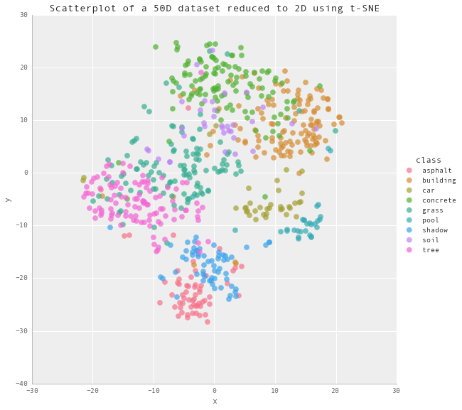

A few of the examples of statistical data visualisation are shown below:

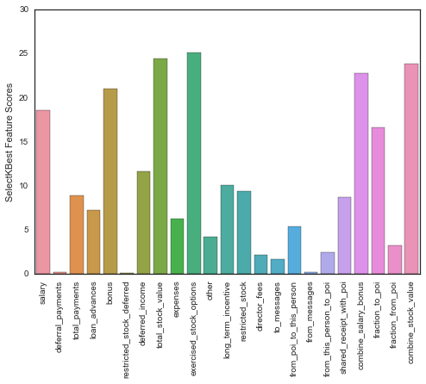

Bar Plot

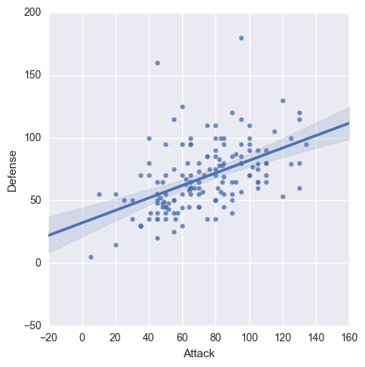
Line Plot

4. DATASET OF THE PROJECT

Our dataset is from Kaggle listed under the name “H-1B Visa Petitions 2011-2016 dataset” .
Kaggle is a platform for predictive modelling and analytics competitions in which statisticians and data miners compete to produce the best models for predicting and describing the datasets uploaded by companies and users. This crowdsourcing approach relies on the fact that there are countless strategies that can be applied to any predictive modelling task and it is impossible to know beforehand which technique or analyst will be most effective.
It contains five year's worth of H-1B petition data, with approximately 3 million records overall. The columns in the dataset include case status, employer name, worksite coordinates, job title, prevailing wage, occupation code, and year filed.
The Office of Foreign Labor Certification (OFLC) generates program data, including data about H1-B visas. The disclosure data is updated annually and is available online. The H1B Visa is a highly desired non-immigrant visa which permits foreign workers in specialty occupations to enter the country. H-1B visas are a category of employment-based, non-immigrant visas for temporary foreign workers in the United States. For a foreign national to apply for H1-B visa, a US employer must offer them a job and submit a petition for a H-1B visa to the US immigration department. This is also the most common visa status applied for and held by international students once they complete college or higher education and begin working in a full-time position.
The first step of the H1B application process is for the U.S. employer to file the H1B petition on behalf of the foreign worker. In the second step, the prevailing and actual wages should be confirmed by the State Employment Security Agency. If the prevailing wage exceeds the offer made by the prospective employer then a wage determination will be sought. The third step of the H1B application process is to file the Labor Condition Application. The next step is to prepare the petition and file it at the proper USCIS office. Processing times for H1B application petitions are subject to vary from location to location. If you would like your petition expedited you may elect for premium processing. The final step of the H1B application process is to check the status of your H1B visa petition by entering your receipt number. Once USCIS has your application on file, they will update your status on their system.

The H-1B Visa Petitions 2011-2016 dataset” initially included about 3 million data points. It contained 7 features and 1 label which can be examined in the given figure.

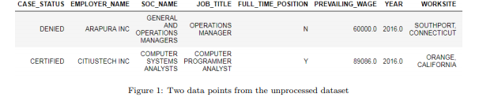

An image of the CSV file of the dataset

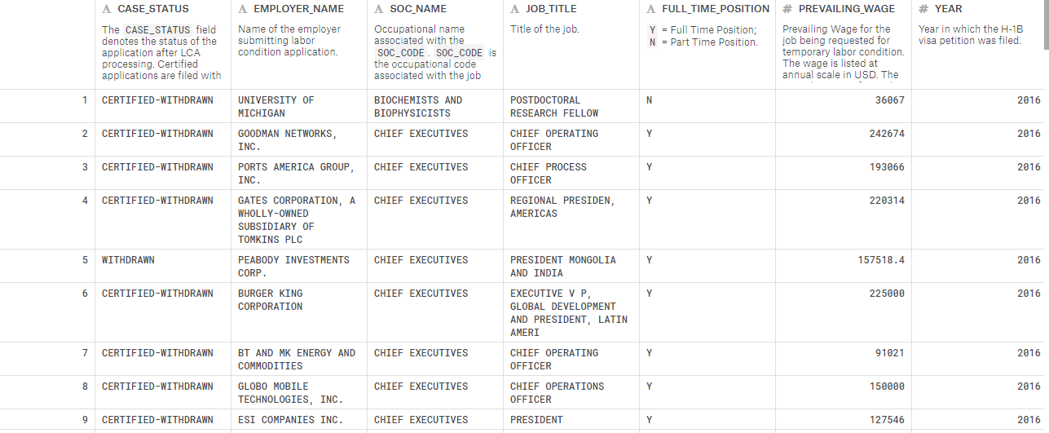

We have the following information for each sample:

The columns in the dataset include:
- CASE_STATUS: Status associated with the last significant event or decision. Valid values include “Certified,” “Certified-Withdrawn,” Denied,” and “Withdrawn”.

- EMPLOYER_NAME: Name of employer submitting labour condition application.

- SOC_NAME: the Occupational name associated with the SOC_CODE. SOC_CODE is the occupational code associated with the job being requested for temporary labour condition, as classified by the Standard Occupational Classification (SOC) System.

- JOB_TITLE: Title of the job

- FULL_TIME_POSITION: Y = Full Time Position; N = Part Time Position

- PREVAILING_WAGE: Prevailing Wage for the job being requested for temporary labour condition. The wage is listed at annual scale in USD. The prevailing wage for a job position is defined as the average wage paid to similarly employed workers in the requested occupation in the area of intended employment. The prevailing wage is based on the employer’s minimum requirements for the position.

- YEAR: Year in which the H1B visa petition was filed

- WORKSITE: City and State information of the foreign worker’s intended area of employment

- lon: longitude of the Worksite

- lat: latitude of the Worksite

5. DATA CLEANSING

Now that we have roughly studied the data, so the data had to be cleansed to analyse.

Data cleansing is sometimes compared to data purging, where old or useless data will be deleted from a data set. Although data cleansing can involve deleting old, incomplete or duplicated data, data cleansing is different from data purging in that data purging usually focuses on clearing space for new data, whereas data cleansing focuses on maximizing the accuracy of data in a system. A data cleansing method may use parsing or other methods to get rid of syntax errors, typographical errors or fragments of records. Careful analysis of a data set can show how merging multiple sets led to duplication, in which case data cleansing may be used to fix the problem.
4.1 STATISTICAL CLEANING :
Many statistical analyses try to find a pattern in a data series, based on a hypothesis or assumption about the nature of the data. 'Cleaning' is the process of removing those data points which are either (a) Obviously disconnected with the effect or assumption which we are trying to isolate, due to some other factor which applies only to those particular data points. (b) Obviously erroneous, i.e. some external error is reflected in that particular data point, either due to a mistake during data collection, reporting etc.
In the process we ignore these particular data points, and conduct our analysis on the remaining data.
'Cleaning' frequently involves human judgement to decide which points are valid and which are not, and there is a chance of valid data points caused by some effect not sufficiently accounted for in the hypothesis/assumption behind the analytical method applied.
The points to be cleaned are generally extreme outliers. 'Outliers' are those points which stand out for not following a pattern which is generally visible in the data. One way of detecting outliers is to plot the data points (if possible) and visually inspect the resultant plot for points which lie far outside the general distribution.

Another way is to run the analysis on the entire dataset, and then eliminating those points which do not meet mathematical 'control limits' for variability from a trend, and then repeating the analysis on the remaining data.
Cleaning may also be done judgementally, for example in a sales forecast by ignoring historical data from an area/unit which has a tendency to misreport sales figures. To take another example, in a double blind medical test a doctor may disregard the results of a volunteer whom the doctor happens to know in a non-professional context.
'Cleaning' may also sometimes be used to refer to various other judgemental/mathematical methods of validating data and removing suspect data.
The importance of having clean and reliable data in any statistical analysis cannot be stressed enough. Often, in real-world applications the analyst may get mesmerised by the complexity or beauty of the method being applied, while the data itself may be unreliable and lead to results which suggest courses of action without a sound basis. A good statistician/researcher (personal opinion) spends 90% of his/her time on collecting and cleaning data, and developing hypothesis which cover as many external explainable factors as possible, and only 10% on the actual mathematical manipulation of the data and deriving results.

The number of samples which we considered for the experimentation was 200,000 (after preprocessing and filtering from 3 million samples). Firstly, we removed all the data points which had ”N/A” or empty values for case status, employer name, year, full-time position and worksite. Here, we had a many null entries (NA), which were then removed and we were left with some 2 million entries to analyse.
The first column was removed as it was unnamed and wasn’t going to affect our analysis in any way.

6. ANALYSIS OF DATASET ON VARIOUS PARAMETERS

There are four types of case application statuses in the dataset. An application can be denied, withdrawn, certified or certified-withdrawn. Certified does not mean that the h1b is approved but it means that the application is approved and is sent for further processing. It is for this very reason, we are unable to fit a model to predict the factors impacting approval of h1b visa applications.

6.1 CALCULATION OF PETITION DISTRIBUTED BY STATUS:

First, checking which case statuses are available in the whole dataset.

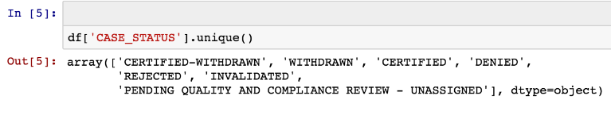

On running python code (written in the code section), we get to know the number of count of all visa statuses available through the dataset. The output in respect to the above code was as follows:

[195721, 84752, 2512114, 85161, 1, 1, 15]

The following bar chart and pie chart on the next page obtained through the code written in python representing various case statuses.

After looking at the plot of case status, we can easily observe that the certified cases dominate this dataset.
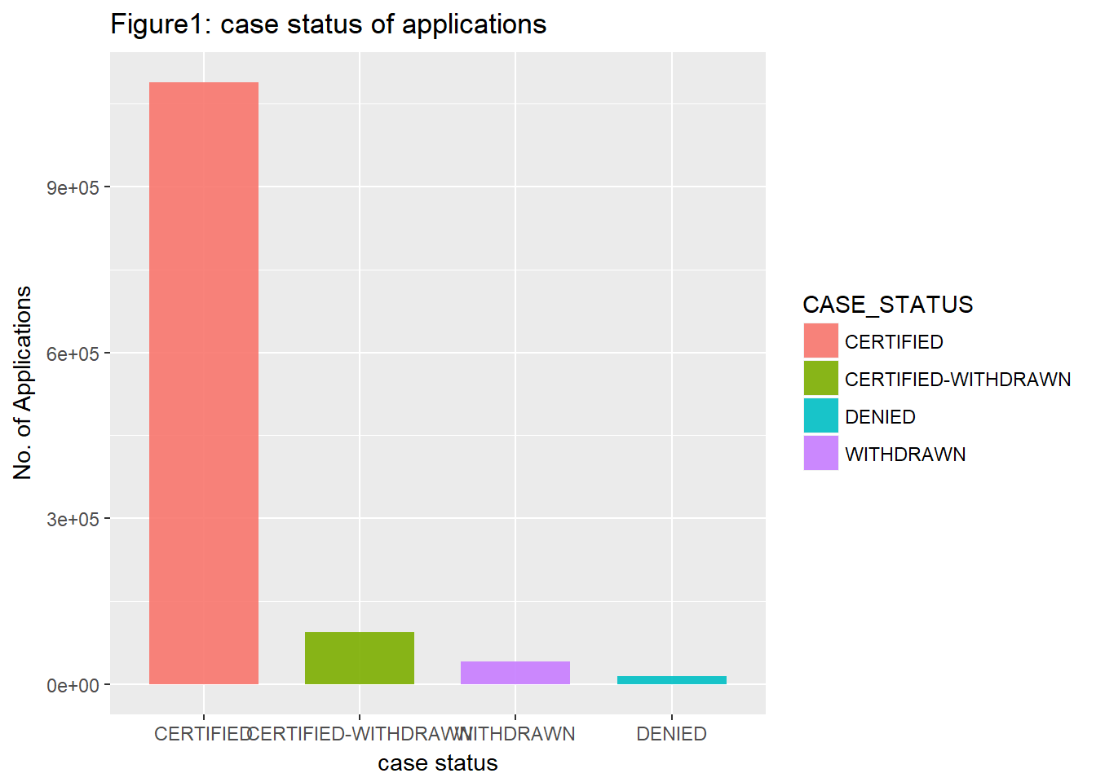

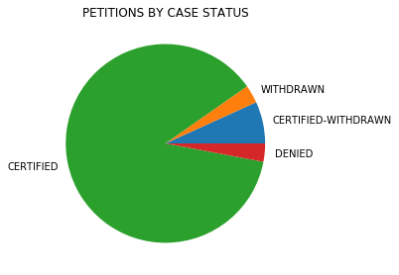

6.2 TOP 5 EMPLOYERS WHO HAVE FILED THE MAXIMUM PETITIONS

Popular H1B Visa Sponsors Companies :
It is always interesting to observe which companies sponsor most number of the h1b applications. It also gives us an indication of the sector in which the maximum number of applications are submitted in.

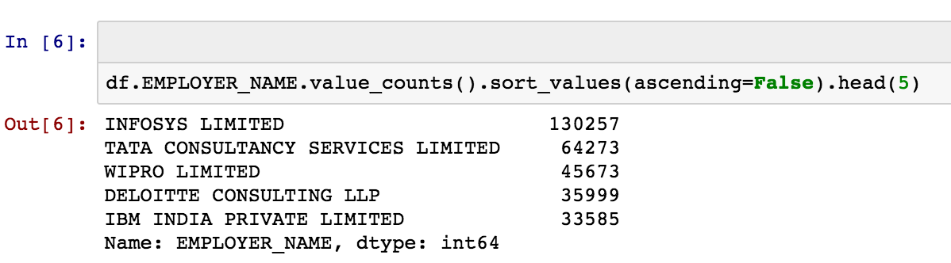

The top 5 employers are known by the above code
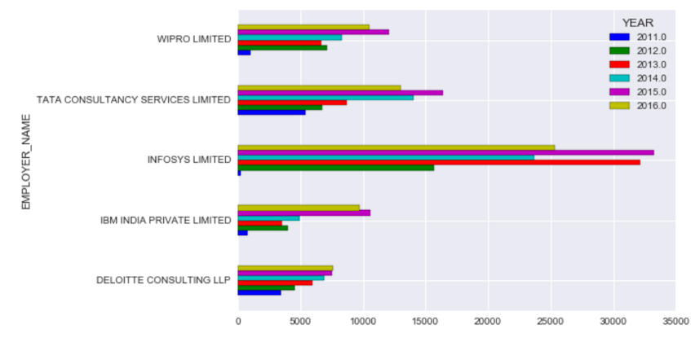

6.3 TOP 15 COMPANIES THAT HAVE FILED THE MOST VISA PETITIONS FROM LAST 5 YEARS :

We explored the data for different employers who file H1-B petitions. Below listed are top 15 employers who file the most number of petitions (code written in the code section) :

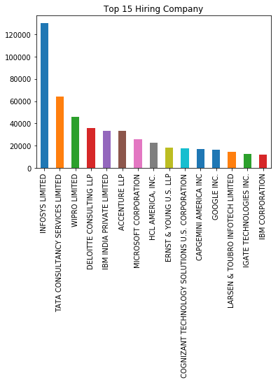

The bar chart tells us that Infosys Limited filed more than twice as many h1b visa applications as Tata Consultancy did . Four out of the top companies in this chart are all Indian information technology companies.

6.4 TOP 15 EMPLOYERS GRANTING HIGHEST PREVAILING WAGES :

This is interesting to know about the top 15 companies providing the highest wages to their foreign employees. On analysing, the following bar chart was obtained :

The top 5 highest prevailing wages are found to be:

Prevailing wages | Frequency
60000.00 | 10185
55245 | 6745
62566 | 6480
58053 | 5683
52499 | 5492

Visual representation of the given analysis through the bar chart is shown in figure 2.
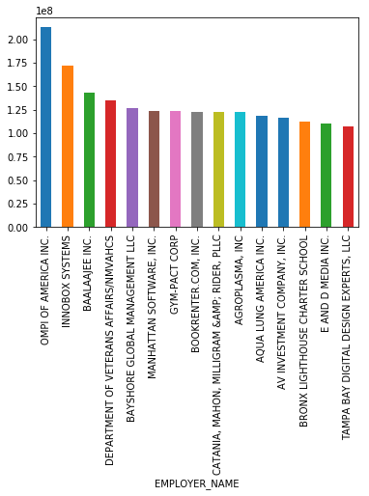

Figure 2 showing the Employers providing highest prevailing wages.

6.5 TOP 20 STATES FROM WHERE MOST OF THE VISA PETITIONS ARE FIRED

The states from where the maximum number of petitions are fired should also be taken into consideration.

In[] : f['WORKSITE'].value_counts().head(20)

NEW YORK, NEW YORK 190863
HOUSTON, TEXAS 83385
SAN FRANCISCO, CALIFORNIA 62457
ATLANTA, GEORGIA 52008
CHICAGO, ILLINOIS 51167
SAN JOSE, CALIFORNIA 49582
SUNNYVALE, CALIFORNIA 34968
DALLAS, TEXAS 31509
BOSTON, MASSACHUSETTS 31336
REDMOND, WASHINGTON 30574
CHARLOTTE, NORTH CAROLINA 30176
IRVING, TEXAS 29316
MOUNTAIN VIEW, CALIFORNIA 29245
SAN DIEGO, CALIFORNIA 28656
SANTA CLARA, CALIFORNIA 27945
JERSEY CITY, NEW JERSEY 26822
SEATTLE, WASHINGTON 26745
AUSTIN, TEXAS 26695
LOS ANGELES, CALIFORNIA 26393
PHILADELPHIA, PENNSYLVANIA 24104

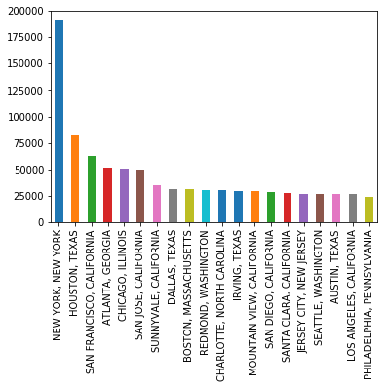

The visual representation of the analysis shows New York State, Texas city of the Houston state and California of San Francisco are among the top states to fill visa petitions followed by Atlanta and Chicago.

6.6 CALCULATING THE PETITION DISTRIBUTION BY YEAR

To analyse the number of petitions fired every year from 2011-2016 and to know the trend during these five years.
The column YEAR with every entry show the year during which petition was fired .
On writing the code the data thus obtained was :

Year | No. of petitions
2011 | 333625
2012 | 394267
2013 | 422427
2014 | 498027
2015 | 600120
2016 | 629299

The visualisation of the analysis is done through plotting a bar graph as:

Year v/s the number of petitions
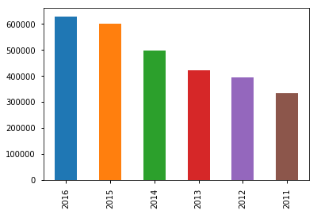

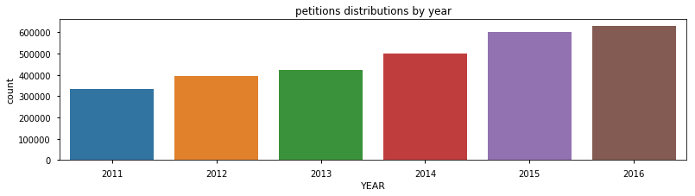

It is clear from the graph that the petitions are increasing every year, the rate of increment was a little less pronounced in the year 2012-2013 and 2015-2016

6.7 To analyse the number of visa petitions denied

The visual analysis of the fraction of visas denied and granted is plotted as:

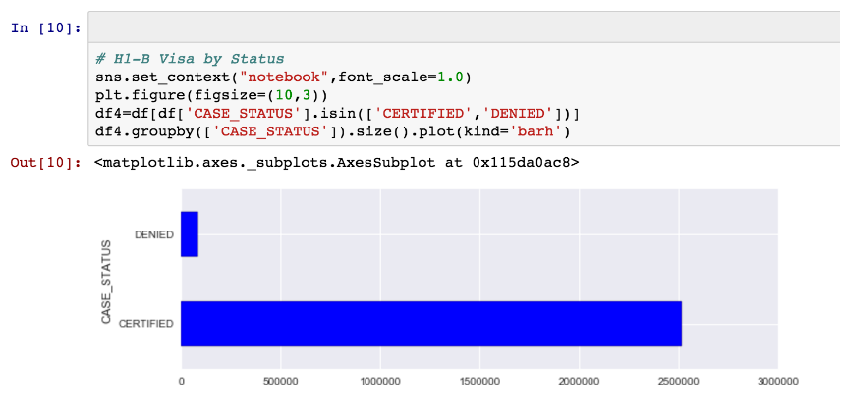

It is clear that for all the visa application filed so far, only 3-5% has been denied but rest of them are Certified

Denied_year_count

Year | Petitions Denied
2011 | 25986
2012 | 18866
2013 | 10976
2014 | 10816
2015 | 10037
2016 | 8480

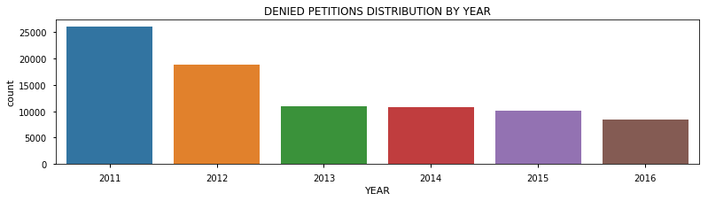

Thus, it is clear that the number of visas denied had decreased from the year 2011 to 2016. But the number of applications were increased too, so the rate of visas denied will be a more accurate measure.

6.8 THE RATE OF VISAS DENIED FROM THE YEAR 2011 TO 2016

Rate of petitions denied was calculated as follows :

Year | Rate of petitions denied
2011 | 7.79
2012 | 4.79
2013 | 2.6
2014 | 2.17
2015 | 1.67
2016 | 1.35

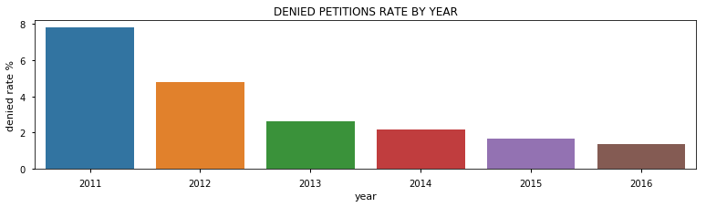

Thus it can now be confidently said that the rate of visa petition denial has decreased from year 2011 - 2016

6.9 To calculate the number of visa petitions filed by the states

Let’s look at the cities with maximum number of submissions and compare the statistics . This will help us understand which cities file a lot of applications. Also, we can see the difference in the number of applications to find out if there is any significant difference in the number of applications in some cities.

To get the names and number of States, we cleanse the data again. We separate the column WORKSITE into Us_states and print them to know which cities are available in our dataset.

Us_states = ['ALABAMA', 'ALASKA', 'ARIZONA', 'ARKANSAS', 'CALIFORNIA',
'COLORADO', 'CONNECTICUT', 'DELAWARE', 'DISTRICT OF COLUMBIA', 'FLORIDA', 'GEORGIA', 'HAWAII', 'IDAHO', 'ILLINOIS', 'INDIANA',
'IOWA', 'KANSAS', 'KENTUCKY', 'LOUISIANA', 'MAINE', 'MARIANA ISLANDS', 'MARYLAND', 'MASSACHUSETTS', 'MICHIGAN', 'MINNESOTA', 'MISSISSIPPI', 'MISSOURI', 'MONTANA', 'NEBRASKA', 'NEVADA', 'NEW HAMPSHIRE', 'NEW JERSEY', 'NEW MEXICO', 'NEW YORK', 'NORTH CAROLINA', 'NORTH DAKOTA', 'OHIO', 'OKLAHOMA', 'OREGON', 'PENNSYLVANIA', 'PUERTO RICO' 'RHODE ISLAND', 'SOUTH CAROLINA', 'SOUTH DAKOTA', 'TENNESSEE', 'TEXAS', 'UTAH', 'VERMONT', 'VIRGINIA', 'WASHINGTON', 'WEST VIRGINIA', 'WISCONSIN', 'WYOMING']

In [ ] : len(Us_states)
Out [ ] : 53

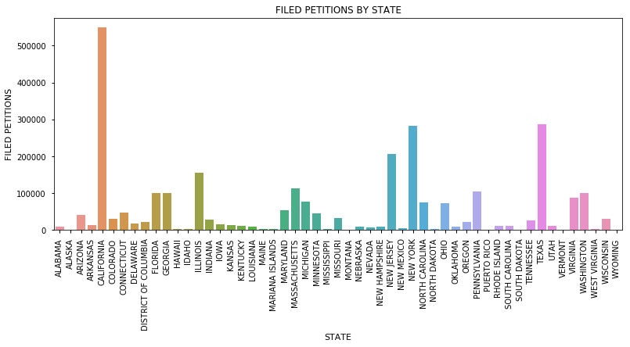

As clear from the graph the highest rate of visa denial is of California, then Texas and then NewYork whereas the petition firing order was not in the same order.

6.10 The rate of denial of visa petition by the States :

Again, the previous analysis isn’t showing the required conclusions as the number of petition fired in California, Texas and NewYork was way more than many of the states. Therefore, for a better interpretation we calculate the rate of denial of the visa petitions.

First, we calculated the rate of denial of the visa for different states. A concise output is shown in the figure below :

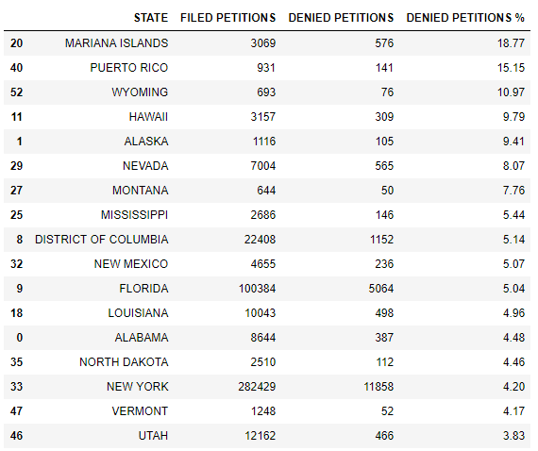

The plot of rate of visa petition denied for states is:

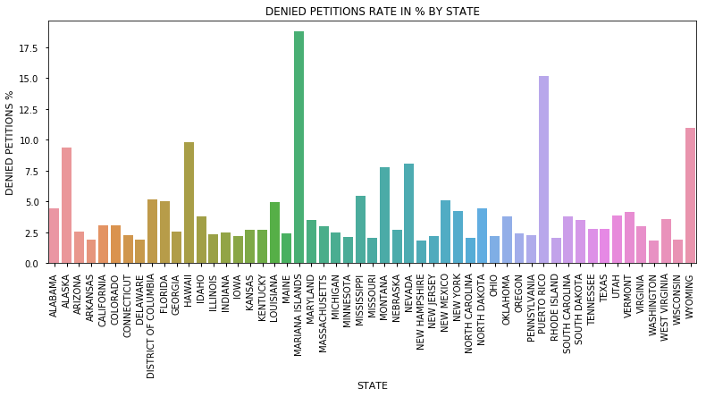

The conclusion is different from the previous analysis. The rate of denial in California and Texas is lower than that of NewYork and other states like Mariana Island , Puerto Rico, Wyoming and Alaska which are the top four states with high rates of visa denial.

6.11 TOP 25 JOB TITLES :

Popular Job Titles by year
Programmer Analyst and Software engineer are the two job titles which attracted the maximum number of h1b applications. It can also be deduced from the job titles that the Information Technology sector uses the maximum number of h1b slots available to be filled.
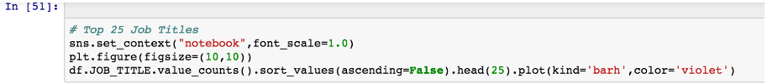
The visualisation plot is as follows :

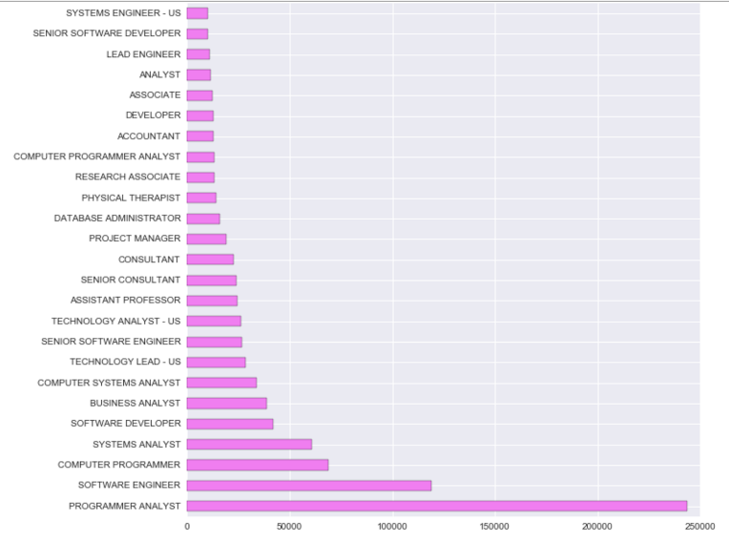

It can be concluded Computer developers, programmers and system analysts are the occupations which contribute to the maximum share of the h1b applications. This suggests that there is a dearth in the number of computer engineers in the United States.

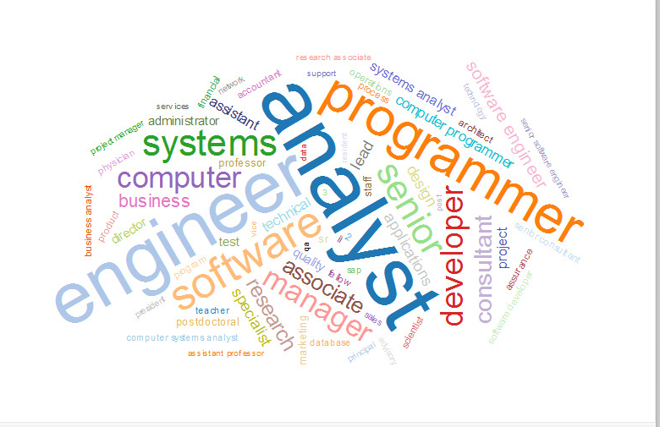

6.12 TO ANALYSE THE FRACTION OF FULL TIME AND PART TIME WOKERS:

Let’s look at the distribution of the number of applications based on full time status. It has been observed that the maximum number of applicants were in a full time role.

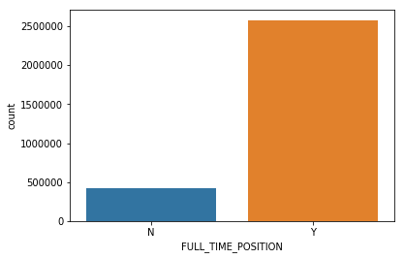

7. CODE OF THE PROJECT

#importing libraries and modules
import pandas as pd
from matplotlib import pyplot as plt
import seaborn as sn
import numpy as np
from decimal import Decimal
%matplotlib inline

#reading the file which is in the csv format (comma seperated variable)
f = pd.read_csv('h1b_kaggle.csv')

#checking the numbers of columns
f.columns

#data cleansing and checking the columns
del f['Unnamed: 0']
f.columns

Index(['CASE_STATUS', 'EMPLOYER_NAME', 'SOC_NAME', 'JOB_TITLE',
'FULL_TIME_POSITION', 'PREVAILING_WAGE', 'YEAR', 'WORKSITE', 'lon',
'lat'],
dtype='object')

#checking the number of length of the dataframe after the first step of data cleansing
len(f)

3002458

#Removing the rows with NA as any of its entries
f = f.dropna()
#checking the top entries of the dataset
f.head()

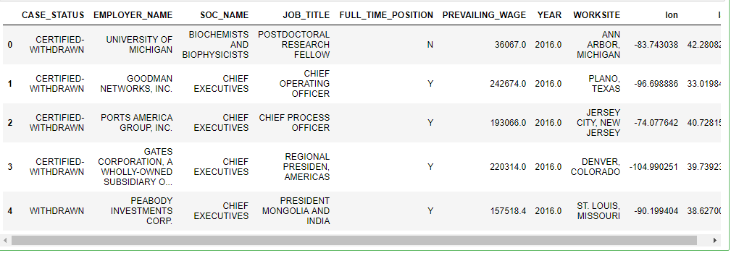

#checking the columns after cleansing
f.columns

Index(['CASE_STATUS', 'EMPLOYER_NAME', 'SOC_NAME', 'JOB_TITLE',
'FULL_TIME_POSITION', 'PREVAILING_WAGE', 'YEAR', 'WORKSITE', 'lon',
'lat'],
dtype='object')

#resetting the index of the columns after removing the unnamed
f.reset_index()
#again checking the length of the dataset after cleaning i.e removing the unwanted columns as well as rows
lng = len(f)
lng

2877765

f.head()

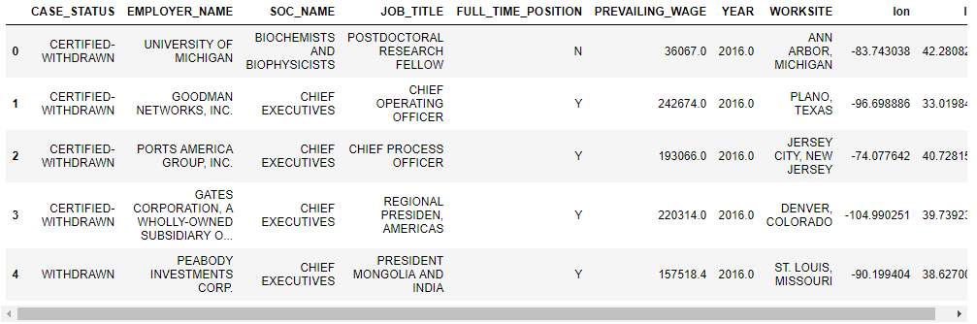

f.EMPLOYER_NAME.value_counts().head()

INFOSYS LIMITED 130257
TATA CONSULTANCY SERVICES LIMITED 64273
WIPRO LIMITED 45673
DELOITTE CONSULTING LLP 35999
IBM INDIA PRIVATE LIMITED 33585
Name: EMPLOYER_NAME, dtype: int64

f['EMPLOYER_NAME'].value_counts().head(15).plot(kind='bar',title='Top 15 Hiring Company')

<matplotlib.axes._subplots.AxesSubplot at 0x204a77915f8>

f.columns

Index(['CASE_STATUS', 'EMPLOYER_NAME', 'SOC_NAME', 'JOB_TITLE',
'FULL_TIME_POSITION', 'PREVAILING_WAGE', 'YEAR', 'WORKSITE', 'lon',
'lat'],
dtype='object')

f.PREVAILING_WAGE.value_counts().sort_values(ascending=False).head()

60000.0 10185
55245.0 6745
62566.0 6480
58053.0 5683
52499.0 5492
Name: PREVAILING_WAGE, dtype: int64

f.PREVAILING_WAGE.mean()

145166.64888402403

awp = f.groupby(['EMPLOYER_NAME']).mean()['PREVAILING_WAGE'].nlargest(15).plot(kind='bar')

f['WORKSITE'].value_counts().head(20)

NEW YORK, NEW YORK 190863
HOUSTON, TEXAS 83385
SAN FRANCISCO, CALIFORNIA 62457
ATLANTA, GEORGIA 52008
CHICAGO, ILLINOIS 51167
SAN JOSE, CALIFORNIA 49582
SUNNYVALE, CALIFORNIA 34968
DALLAS, TEXAS 31509
BOSTON, MASSACHUSETTS 31336
REDMOND, WASHINGTON 30574
CHARLOTTE, NORTH CAROLINA 30176
IRVING, TEXAS 29316
MOUNTAIN VIEW, CALIFORNIA 29245
SAN DIEGO, CALIFORNIA 28656
SANTA CLARA, CALIFORNIA 27945
JERSEY CITY, NEW JERSEY 26822
SEATTLE, WASHINGTON 26745
AUSTIN, TEXAS 26695
LOS ANGELES, CALIFORNIA 26393
PHILADELPHIA, PENNSYLVANIA 24104
Name: WORKSITE, dtype: int64

f['WORKSITE'].value_counts().head(20).plot(kind='bar')

f.loc[:,'WORKSITE'].head()

0 ANN ARBOR, MICHIGAN
1 PLANO, TEXAS
2 JERSEY CITY, NEW JERSEY
3 DENVER, COLORADO
4 ST. LOUIS, MISSOURI
Name: WORKSITE, dtype: object

f.loc[:,'WORKSITE'] = f.loc[:,'WORKSITE'].apply(lambda s:s.split(',')[1][1:])
f.head()

def change_NA(rec):
if (rec == 'NA') :
return 'MARIANA ISLANDS'
return rec
f.loc[:,'WORKSITE'] = f.loc[:,'WORKSITE'].apply(lambda rec : change_NA(rec))
print(len(f.loc[:,'WORKSITE'].unique()))

f.columns

f.rename(columns={'EMPLOYER_NAME':'EMPLOYER','FULL_TIME_POSITION':'FULL_T','PREVAILING_WAGE':'PREV_WAGE','WORKSITE':'STATE','lon':'LON','lat':'LAT'},inplace=True)

columns_to_keep = [ 'CASE_STATUS','YEAR','STATE','SOC_NAME','JOB_TITLE','FULL_T','PREV_WAGE','EMPLOYER',]

f = f[columns_to_keep]
f.columns

#f['LON'] = f['LON'].apply(lambda lon: float("%.2f"%lon))
#f['LAT'] = f['LAT'].apply(lambda lon: float("%.2f"%lon))
f['YEAR'] = f['YEAR'].apply(lambda year:'%g'%(Decimal(str(year))))
f['PREV_WAGE'] = f['PREV_WAGE'].apply(lambda wage:'%g'%(Decimal(str(wage))))

f.head(3)

f['CASE_STATUS'].unique()

#Calculating the number of petitions applied every year
status_freq = [0]*7
statuses =['CERTIFIED-WITHDRAWN', 'WITHDRAWN', 'CERTIFIED', 'DENIED',
'REJECTED', 'INVALIDATED',
'PENDING QUALITY AND COMPLIANCE REVIEW - UNASSIGNED']
for i in range(0,7):
status_freq[i] = f[f.CASE_STATUS==statuses[i]]['CASE_STATUS'].count()
status_freq

from matplotlib.pyplot import pie,axis,show
import matplotlib as mpl

plt.figure(figsize=(4.5,4.5))
plt.title('PETITIONS BY CASE STATUS')
axis('equal')
pie(status_freq[:4],labels=statuses[:4])
show()

#Calculation number of petitions filed every year
years = [ '2011','2012','2013','2014','2015','2016']
year_count = [0]*6
for i in range(0,6):
year_count[i] = f[f.YEAR == years[i]]['YEAR'].count()
year_count

sn.set_context("notebook",font_scale=1.0)
plt.figure(figsize=(13,3))
plt.title('petitions distributions by year')
sn.countplot(f['YEAR'])

<matplotlib.axes._subplots.AxesSubplot at 0x204cba83a90>

k = f['YEAR'].value_counts()
k.plot(kind='bar',)

<matplotlib.axes._subplots.AxesSubplot at 0x204a6046400>

plt.figure(figsize=(13,3))
plt.title('petitions distributions by year')
plt.hist(f['YEAR'])
plt.show()

denied = f[f.CASE_STATUS == 'DENIED']
len(denied)

del denied['CASE_STATUS']

denied = denied.reset_index()
denied.head(3)

denied_year_count = [0]* 6
for i in range(0,6):
denied_year_count[i] = denied[denied.YEAR == years[i]]['YEAR'].count()

denied_year_count

sn.set_context("notebook",font_scale=1.0)
plt.figure(figsize=(13,3))
plt.title('DENIED PETITIONS DISTRIBUTION BY YEAR')
sn.countplot(denied['YEAR'])

denied_year_rate = [0]*6
for i in range(6):
denied_year_rate[i] = float("%.2f"%((denied_year_count[i]/year_count[i]*100)))
ratio = pd.DataFrame()
ratio['year'] = years
ratio['denied rate %'] = denied_year_rate
ratio = ratio.set_index(['year'])
ratio.T

ratio = ratio.reset_index()
sn.set_context('notebook',font_scale=1.0)
plt.figure(figsize=(13,3))
plt.title('DENIED PETITIONS RATE BY YEAR')
g = sn.barplot(x='year',y='denied rate %',data=ratio)

#Calculating number of petitions filed by the states
f.columns

l = list(f['STATE'].unique())
l.sort()
print(l)

Us_states= ['ALABAMA', 'ALASKA', 'ARIZONA', 'ARKANSAS', 'CALIFORNIA',
'COLORADO', 'CONNECTICUT', 'DELAWARE', 'DISTRICT OF COLUMBIA',
'FLORIDA', 'GEORGIA', 'HAWAII', 'IDAHO', 'ILLINOIS', 'INDIANA',
'IOWA', 'KANSAS', 'KENTUCKY', 'LOUISIANA', 'MAINE', 'MARIANA ISLANDS',
'MARYLAND', 'MASSACHUSETTS', 'MICHIGAN', 'MINNESOTA', 'MISSISSIPPI', 'MISSOURI',
'MONTANA', 'NEBRASKA', 'NEVADA', 'NEW HAMPSHIRE', 'NEW JERSEY',
'NEW MEXICO', 'NEW YORK', 'NORTH CAROLINA', 'NORTH DAKOTA',
'OHIO', 'OKLAHOMA', 'OREGON', 'PENNSYLVANIA', 'PUERTO RICO',
'RHODE ISLAND', 'SOUTH CAROLINA', 'SOUTH DAKOTA', 'TENNESSEE',
'TEXAS', 'UTAH', 'VERMONT', 'VIRGINIA', 'WASHINGTON',
'WEST VIRGINIA', 'WISCONSIN', 'WYOMING']
len(Us_states)

petitions_by_state = [0]*53
for i in range(53):
petitions_by_state[i] = f[f.STATE==Us_states[i]]['STATE'].count()
pet_state = pd.DataFrame()
pet_state['STATE'] = Us_states
pet_state['FILED PETITIONS'] = petitions_by_st
ate
print(sum(petitions_by_state))

sn.set_context("notebook",font_scale=1.0)
plt.figure(figsize=(13,5))
plt.title('FILED PETITIONS BY STATE')
v = sn.barplot(x='STATE',y='FILED PETITIONS',data=pet_state)
rotg = v.set_xticklabels(v.get_xticklabels(),rotation=90)

#Number of petitions denied by the state
denied_by_state = [0]*53
for i in range(53):
denied_by_state[i] = denied[denied.STATE == Us_states[i]]['STATE'].count()
den_state = pd.DataFrame()
den_state['STATE'] = Us_states
den_state['DENIED PETITIONS'] = denied_by_state
print(sum(denied_by_state))

sn.set_context("notebook",font_scale=1.0)
plt.figure(figsize=(13,5))
plt.title('DENIED PETITIONS BY STATE')
v = sn.barplot(x='STATE',y='DENIED PETITIONS',data=den_state)
rotg = v.set_xticklabels(v.get_xticklabels(),rotation=90)

denied_state_rate = [0]*53
for i in range(53):
denied_state_rate[i] = float("%.2f"%((denied_by_state[i]/petitions_by_state[i])*100))

ratios = pd.DataFrame()
ratios['STATE'] = Us_states
ratios['DENIED PETITIONS %'] = denied_state_rate

sn.set_context("notebook",font_scale=1.0)
plt.figure(figsize=(13,5))
plt.title('DENIED PETITIONS RATE IN % BY STATE')
v = sn.barplot(x='STATE',y='DENIED PETITIONS %',data=ratios)
rotg = v.set_xticklabels(v.get_xticklabels(),rotation=90)

pet_state['DENIED PETITIONS'] = denied_by_state
pet_state['DENIED PETITIONS %'] = denied_state_rate
pet_state = pet_state.sort_values(by='DENIED PETITIONS %',ascending=False)
pet_state

#Now we will focus on the Job_Position 'DATA SCIENTIST'
f[f['JOB_TITLE']=='DATA SCIENTIST']['JOB_TITLE'].count() #Total H1B Applications for Data Scientist
#H1B Applications for a Data Scientist split by every Year
f[f['JOB_TITLE']=='DATA SCIENTIST'].groupby('YEAR')['JOB_TITLE'].count()

#We observe the number of applications increasing exponentially each year.The reason for it is the demand for DataScientist is increasing and it is the hot job of 20th century.

#Top 10 Companies that apply for H1B application for the Position of Data Scientist
f[f['JOB_TITLE']=='DATA SCIENTIST']['EMPLOYER_NAME'].value_counts().head(10)
# Now again we will focus for DATA SCIENTIST
# Mean Salary of all the Wages for a CERTIFIED Data Scientist in all the State
f[(f['JOB_TITLE']=='DATA SCIENTIST') & (f['CASE_STATUS']=='CERTIFIED')].groupby('WORKSITE')['PREVAILING_WAGE'].mean().nlargest(10)
#Mean Wage of a Data Scientist with Case_Status Certified is highest in California.
#Mean wage of a Data Scientist with status as certified in California for each Year.
f[(f['WORKSITE']==' CALIFORNIA') & (f['CASE_STATUS']=='CERTIFIED') & (f['JOB_TITLE']=='DATA SCIENTIST')].groupby('YEAR')['PREVAILING_WAGE'].mean()
#Calculating the number if petitiond denied in a state Illinois
illinois = f[f.STATE == 'ILLINOIS'] #SUBSET OF ILLINOIS PETITIONS
del illinois['STATE']
#del illinois['LON']

#del illinois['LAT']
illinois = illinois.reset_index()
lnh = len(illinois)
print(lnh,'petitions were filed in Illinois and 3612 of them were denied.')

def get_data(rec):
if (rec.find('CHIEF PROCESS OFFICER') < 0) :
return 'NO_DATA'
return rec
illinois.loc[:,'JOB_TITLE'] = illinois.loc[:,'JOB_TITLE'].apply(lambda rec:get_data(rec))
illinois_data = illinois[(illinois.JOB_TITLE != 'NO_DATA') & ( illinois.CASE_STATUS != 'DENIED')]
print(len(illinois_data),'petitions for the job of "CHIEF PROCESS OFFICER" in the state of','illinois were certified')

illinois_data

#Top 25 job titles
f.JOB_TITLE.value_counts().sort_values(ascending=False).head(25)

#Plotting the graph for top 25 job titles
f['JOB_TITLE'].value_counts().head(25).plot(kind='bar',title='Top 25 Job Titles')
sns.set_context(“notebook”,font_scale=1.0)
plt.figure(figsize=(10,10))
f.JOB_TITLE.value_counts().sort_values(ascending=False).head(25).plot(kind=”barh”,colour=”violet”)

#To plot a graph of full-time workers compared to part-time workers
sns.countplot(x=f[FULL_TIME_POSITION])

8. CONCLUSION

Exploratory data analysis was performed on the h1b petition dataset for the years 2011 to 2016 and following conclusions were made.
Anesthesiologists are the top earners among all the occupations. Anesthesiologist MD are the top earners.
California and Washington are the states with highest median wages among all the applicants across all the states in the United States. Their median wage is approximately 95k.
It is observed that California has the maximum number of submissions, followed by Texas, but, with only as many as half the number of submissions as that of California.
We see that New York has the maximum number of applications. Houston and San Francisco come in distant second with less than half the number of applications submitted in New York. Among all the top 10 states, .
Infosys Limited filed more than twice as many h1b visa applications as Tata Consultancy did in during the years. Four out of the top ten companies in this chart are all Indian information technology companies.
Information Technology sector uses the maximum number of h1b slots available to be filled.
Computer developers, programmers and system analysts are the occupations which contribute to the maximum share of the h1b applications. This suggests that there is a dearth in the number of computer engineers in the United States.
This analysis provides quick information about the sectors in which there is lack of local talent and foreign resources are needed. This provides insights to universities/ job seekers to learn these technologies/skills to find a better job in the United States. One can also see which job roles are top paying. Also, h1b seekers will get a fair idea on the companies that sponsor the maximum share of h1b applications in the Unites States.

9. REFERENCE

https://www. kaggle.com/nsharan/h-1b-visa
https://en.wikipedia.org/wiki/H-1B_visa
www.stackoverflow.com
https://www.python.org/

